**Automation Framework:**

This automation framework mostly based on Libraries (Methods) and Test Cases.

Framework contain four folders structure.

1. bin
2. include
3. log
4. TestCase

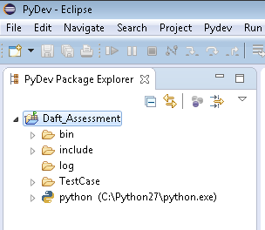

**Bin ->** Bin contain config file (config.ini) and master script (Start.py)

**Include ->** Include contain all libraries or methods files which we are using in test cases.

**Log->** Log folder contain all logs.

**TestCase->** Folder contain all test cases with different tasks and test cases list also. (.csv file)

**Under Bin:-**

**config.ini:**

All global variable are declared in that file.

**Start.py:**

This is master script where we can run the test suite. This script will create test cases list which will passed on the “Task_API” and “Task_UI” function. This framework also handle sequential and parallel mode for which we are using python “concurrent.futures.ThreadPoolExecutor” module. We need to just define this parameters in config.ini file.

**Under Include:-**

**apihelper.py:**

This helper contain API related methods such as getResponseMsg and validateResponse. This API are used in Task 2

**baseuihelper.py:**

This helper contain UI related methods, this UI methods are used in Task 1

**commonhelper.py:**

This is helper are used in both task, it contain saveResultsOfTestcase and writeToLogFile methods

**CommonTest.py:**

BaseTest is abstract base class for Testcase objects and each Testcase class must derive from this class. If derived class do not define any of the functions, an exception of type NotImplementedException will be thrown

**Config.py:**

This helper method to parse the ini file



**Future Enhancements:**

1. We can create a good and user friendly HTML report using “summaryresult.log”. we have to write one parser function the input parameter are summaryresult.log and it will create a HTML report with total no of Test case RUN, FAIL and PASS.
2. Right now I am dumping all logs in log folder, we need to write one function it will create a separate folder with each test case ID’s.
3. We can create one function to take backup of old logs.